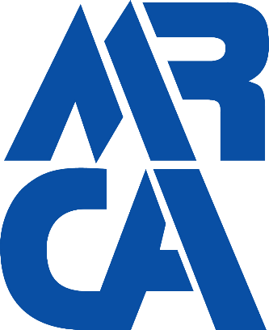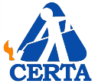

The Midwest Roofing Contractors Association Video Conference Based
Certified Roofing Torch Applicators (CERTA)
Roofing Torch Safety Training and Evaluation Program Guide

Contents
Welcome to the MRCA’s Certified Roofing Torch Applicator 3
Video Conference-Based Training Program 3
MRCA Video Conference Based Certification Classroom requirements 4
Certification Classroom Requirements 5
A note about language 6
CERTA – Administrative Services Contact 6
CERTA Hands-On Practice and Practical Evaluation 7
Preparing for the hands-on evaluation 7
Documentation 7
Required Roof Detail Mockups 7
Required Equipment – Propane Tanks 8
Required Equipment - Fire Extinguishers 8
Required Equipment - Roofing Torch Assembly 8
Personal Protective Equipment 8
Getting Started – Hands-On Evaluation Forms 9
Organizing your evaluations 9
Instructions for Scoring the Evaluations 9
Step 1 Igniting the torch 10
Step 2: flashing torch and flop on a curb or a wall 11
Step 3 Field mock-up stations 3 and 4: starting field membranes at roof edges or walls 12
Step 4 Installing target sheet at the drains. 13
Step 5 Field mock-up stations 3 and 4: installing field membrane over drain 14
Step 6 Field mock-up stations 3 and 4: installing field membrane around pipe penetration 15
Step 7 Field mock-up stations 3 and 4: ending field membranes at roof edges and walls 16
Step 8 Shutting off the torch 17
Cycling Through the Evaluation Stations and Completing the evaluation form. 18
CERTA – Technical Services Hands on Help Line Contact Information 19
Finalizing your Training Program 19

Welcome to the MRCA’s Certified Roofing Torch Applicator

Video Conference-Based Training Program

Thank you for making the effort to participate in the new MRCA Certified Roofing Torch Applicator (CERTA) Video Conference-Based Training Program. CERTA has changed the way workers use torches. Roofing workers today are using torches more carefully thanks to the implementation of the safety practices learned in CERTA roofing torch safety classes. The decisions they make and actions they take while using roofing torches contributes to the safe and successful application of torch-applied roof systems.
This MRCA ‘s Video Conference Based Training Program Guide provides specific instructions to prepare for and facilitate successful CERTA training sessions to certify torch users. These instructions outline the requirements for Video Conference Classrooms and for the practical Hands-On Evaluation required of each student in this program.
In 1986, the Midwest Roofing Contractors Association (MRCA), in conjunction with the Asphalt Roofing Manufacturers Association and the United Union of Roofers, Waterproofers and Allied Workers, developed a curriculum for training roofing workers in the safe application or torch-applied roof systems. This program was named the Certified Roofing Torch Applicator program, or CERTA.
In 2003, the insurance industry approached NRCA to address concerns about increasing incidents and losses occurring during torching activities by roofing contractors. NRCA recognized two things: Torching activities were, and will continue to be, a part of the roofing industry; and roofing workers traditionally have learned many skills, including torch use, through on-the-job techniques. This training method was not adequately addressing the safety concerns, and the need for focused training for safe torch use became apparent. NRCA adopted and revised the CERTA program to meet this need.
In 2020, the MRCA stepped up to create a video conference based program to meet the needs for live, in person training in the post COVID19 era. This program provides highly qualified instructors in a MRCA controlled framework to meet your training needs while permitting your employees to cohort with the same people that they work with and not be exposed to the risk of working in close quarters with people outside of your group.
The MRCA’s program continues to provide the same safety practices and industry requirements for torching activities as before. The program includes classroom instruction, student manual, video and hands-on training. There is no comparable safety training program available in the roofing industry. Only MRCA authorized trainers will teach every CERTA class and preside over all hands-on evaluations.
Upon successful completion of CERTA certification training, all participants will be able to:
- List personal protective equipment (PPE) requirements for torching activities
- Describe basic first-aid procedures associated with torching injuries
- Explain proper steps and procedures for handling propane gas cylinders
- Identify components of a torch assembly
- Demonstrate safe assembly, lighting and use of torch equipment
- Identify the key elements of a comprehensive pre-job inspection
- Recognize hazardous areas for torching
- Prescribe hazard controls when torching near hazardous areas
- Demonstrate safe torching techniques near hazardous areas
- Explain post-job fire watch and other duties

Upon successful completion of each class participants will be Certified Roofing Torch Applicators. CERTA identification cards will be issued to those who become certified, and a list of certified applicators will be maintained in the NRCA database. This certification is valid for three years though it may be rescinded at any time if a certified worker is observed performing unsafe work practices.

MRCA Video Conference Based Certification Classroom requirements
For you or your company to successfully complete the MRCA’s CERTA training program you must attend a video conference based classroom session and participate in a hands-on practical evaluation of your skills to demonstrate your understanding of the CERTA program’s requirements.
There are two types of CERTA classes offered in the Video Conference format. Open classes have no restrictions upon who may register for the class and Private classes which are classes offered to a single contractor only who does not want to have other employer participants attending with his group. Classes are offered in English or Spanish and, while many native Spanish speakers are conversant in English, we have created Spanish only classes to provide dedicated services to this segment of the workforce.
Prior to the start of each class you will be required to submit a roster listing the name and home address for each participant. The CERTA program certifies individuals, not companies and each certification is valid for 3 years from the date of the class. CERTA identification cards will be issued to those who become certified, and a list of certified applicators will be maintained in the NRCA database.
Participating in a CERTA training session does not guarantee participants become certified roofing torch applicators. There are two program requirements that must be satisfied before participants can be approved for certification:
- A 70 percent or higher score on the exam
- Passing evaluations on a peer-rated performance evaluation for the hands-on portion of the class
Upon completion of the class you must re-submit a final roster with any adjustment in attendees, the complete exam grades, and hands-on performance evaluation results along with video documentation of your hands-on session. If there is a difference in the number of attendees, the MRCA will either bill or refund the credit card that you originally used to pay the fees for the session.
Each class begins with a review of the CERTA video produced by the NRCA. We will use this video to demonstrate the components of the roofing torch fire safety program. The video is followed by a videoconference based classroom presentation to explain the theory behind fire safety and the requirements of the mandatory fire safety inspections and fire watch program required by CERTA.
For all MRCA Safety Video Conference based training and certification sessions the following requirements must be met.
- Participants must be registered in advance of the start of the class.
  - All participants must sign the final Roster provided by the proctor or group captain.
  - The Roster must include the Date, Location, Name, Home Address and Signature of each attendee.
  - Each class group shall have a designated Proctor assigned to monitor the class attendance and assist with the distribution of documents when required.
- All class groups are required to attend the Video Conference based class in a classroom, conference room or office type setting.

  - For each class group there must be a minimum of one laptop computer with broadband internet access.
  - The classroom must be equipped with at least one Video Camera, a Microphone and Speakers.
  - It is not acceptable to use cell phone video or dial in only services.
- All Class Groups are required to utilize a video camera so that the participants can always be viewed by the instructor.
  - If occasionally the need arises for a participant to step away from the class, then the instructor and/or the proctor must be notified.
  - Absences for more than a total of 20 minutes per class session may cause the participant to fail.
- Prior to the start of the class each group will be emailed a Video Conference meeting sign in link. Class video conferences will be held using MS Teams.
  - Each participant (or group) is encouraged to log into the MS Teams platform in advance to download any client software required.
  - All participants will be provided free access to the classroom so please do not buy an account unless you want to.
  - Complete instructions for First Time Video Conference users are included as a separate download in the package. Please take a few minutes in advance of the class to familiarize yourself with the process.
- It is preferable that the computer system used be connected to a larger video screen so that all participants may view the presentations.
  - If you are using laptop computers only then we must limit the number of users per laptop to 4. For example, a class group of 10 people using only laptop monitors must use at least three laptops.
  - All Video Conference based training will be recorded for auditing purposes.
- The MRCA requires training to be interactive and the failure of any participant to respond when questioned by the instructor may cause the participant to fail the training.

Certification Classroom Requirements
For each class group please arrange to have the following items available in advance of the class:
- Student manuals – one copy for each participant
- Smart monitor or computer screen large enough for everyone to see, connected to the internet with the Microsoft Teams client installed
- Roofing materials, including two small samples pieces of each of the following:

  - Wood fiberboard roof insulation
  - Polyisocyanurate insulation
  - DensDeck® gypsum board
  - Wood fiber cant strip
  - SBS polymer-modified bitumen membrane
  - APP polymer-modified bitumen membrane
  - Heavy glass base sheet
  - Type IV glass ply sheet
  - Self-adhering, modified bitumen base sheet

Additionally, there are several downloadable required documents that you must prepare and have ready for the class. The list of items is

- Roster & Sign in Sheet
- The CERTA Student Manual - English
- The CERTA Student Manual - Spanish
- The Daily Inspection Checklist - English
- The Daily Inspection Checklist -Spanish
- Exam – English & Spanish
- Exam Answers – English & Spanish
- Mockup Instructions

A note about language:
As you know we have a large Spanish speaking installer base, many of which are conversant in English. While we prefer to provide instruction in only one language, we realize that this may not always be practical. We will make all attempts to assist native Spanish speakers in blended classes and we encourage you to print the student manuals and checklist for each of your Hispanic participants.
While certain classes will have bi-lingual instructors we wish to refrain from conducting bi-lingual classes because it takes away from the time given to the speakers of the primary language. You can check to see which of the Open Classes are being taught with a bilingual instructor or arrange a private class that suits your needs.

CERTA – Administrative Services Contact
There is a CERTA help line for all questions regarding administrative issues such as class registration and scheduling, rosters and payments please call (937) 306-2132 or write CERTA.Info@mrca.org .

CERTA Hands-On Practice and Practical Evaluation

The MRCA has prepared a second video in support of the Video conferenced based training program that will show you how to set up and conduct the hands-on evaluation requirement of your CERTA training program. This video will show you each of the evaluation steps and what constitutes a poor, fair or excellent grade for each of the evaluations eight (8) steps.
A completed performance evaluation form for each participant must be submitted to the MRCA upon completion of this evaluation along with a simple video of the evaluation in progress. You can make this video with an ordinary cell phone. You will send the scanned evaluation forms and a copy of the video to the email address we have provided in your evaluation packet, and again at the end of this video.

Preparing for the hands-on evaluation
To begin the hands-on evaluation portion of the program, you will choose a group captain who will oversee managing the evaluation forms and the video of each participant.
All groups will be broken up into smaller teams of 3 or 4 people to work on the various stations of the mockups. Your video will begin by showing an overview of your mockup area and equipment and you must show a view of the person or people being evaluated. It is ok to speak on the video, so please state the name of your company and the names of the people in the group so we know who you are. It will be helpful if you also write your session identification number on a piece of paper and record this at the beginning of your video.
It will be easiest if you appoint one person from each team to video the team and just send all the separate clips together with the evaluation forms. To summarize, at the beginning of the session you will distribute the evaluation forms found the instructions and at the end of the evaluation, you will submit both the completed evaluation forms and the video clips to the MRCA.

Documentation
To successfully complete the evaluation, you will be required to submit basic video clips of your hands-on evaluation. This can be easily accomplished using any ordinary cell phone with an integrated video camera.

Required Roof Detail Mockups
To prepare for the hands on evaluations you must create an evaluation area that provides for a simulated roof field, a roof edge, a high penetration (like a pipe), a curb or wall and a simulated drain. There are both standard and alternate mockup instructions in your evaluation package.
For those contractors who do not have dedicated training mockups we will accept the demonstration of the torching techniques on the alternate mockup. These instructions are provided in your registration package. If you would like to create a dedicated training area the standard mockup is recommended.
In our post COVID-19 world we want to make sure that all participants in the CERTA program are observing social distancing and are always using masks. We strongly suggest that you create enough space for participants to social distance and that you sanitize equipment between users.

Required Equipment – Propane Tanks
Once you have created your mockup, we will need to provide for the equipment that you must have to successfully complete this evaluation.
The first item required is a propane tank. A minimum 20lb DOT tank like you would find for a gas grill is sufficient, anything larger will do as well. This is a common DOT approved cylinder that has a POL valve, a protective collar, a body that is in good condition and a foot ring. You will need one tank for every four people participating in the evaluation.

Required Equipment - Fire Extinguishers
The CERTA program also requires that you have one extinguisher for every torch and one additional extinguisher near the exit to your work area. Remember to use at least 4A-60BC fire extinguishers. There are identifying icons on the label of each fire extinguisher indicating the type and the size of the extinguisher. This is usually found in the fine print on the extinguisher’s label.
You must have your fire extinguishers placed within 10 feet of your torching activities and your fire extinguishers must be more than 10 feet apart from your propane tanks

Required Equipment - Roofing Torch Assembly
The next items you are required to have are a roofing torch and a detail torch. Many times, roofing field torches and detail torches are sold as combination kits. If you do not have a detail torch you can let us know and we will help you get one. The most important element of this program is the requirement to switch to detail torches when you must reduce the size of the flame over combustible substrate. It does not matter what brand of roofing torch you use, what is important is that you use the correct size torch for your activity.
Again, if you do not use a small detail torch for the direct torching required in the evaluation then we cannot allow you to successfully complete this portion of the class, so…please remember that this is also part of your evaluation.

Personal Protective Equipment
When conducting this evaluation all participants must wear personal protective equipment. This includes long sleeve shirts, long pants, work boots, gloves, and eye protection. All students are encouraged NOT to wear their good clothes, short pants or short sleeve shirts. Wearing short pants or short sleeve shirts puts the participant at risk for a burn injury. While we know that many roof mechanics will wear short sleeve shirts to work on warm days this practice must be discouraged and will cause the participant to receive a “poor” mark on the PPE section of your hands on evaluation.

Getting Started – The Hands-On Evaluation Form

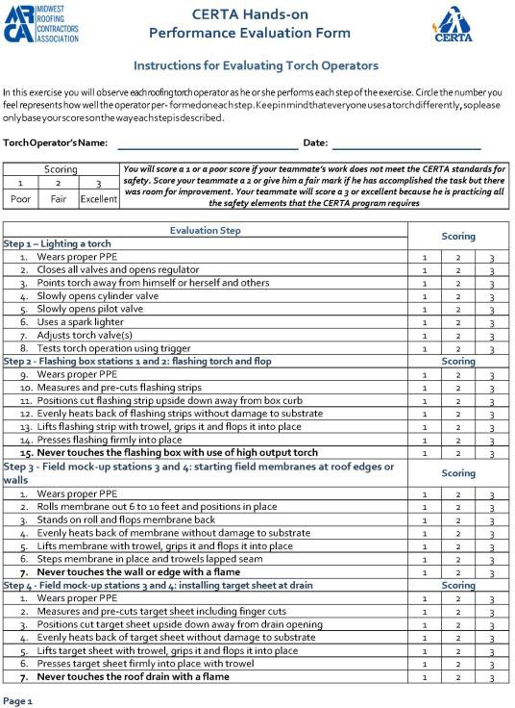Each evaluation requires that all members of your group have a copy of the evaluation form, included in your downloadable package. Everyone will be scored for each of the following steps.
- Lighting a roofing torch
- Flashing torch and flop techniques
- Starting field membranes at roof edges or walls
- Installing target sheets over roof drains
- Installing the field membrane over the roof drain
- Installing field membrane around pipe penetrations
- Ending field membranes at roof edges or walls
- And shutting off the torch

Organizing your evaluations
We will begin the hands on by separating your group into teams of four or less and each team will take turns completing the torching activity on each station. The group members not actively torching will grade the torch applicator on all aspects of torch use for each of the steps.
Each team will appoint a leader who will coordinate the
group’s activities and each member of the team will have an evaluation form. Each group will start at a different workstation.
As the group completes the work at each workstation they will rotate to the next station until all the steps have been completed.

Instructions for Scoring the Evaluations
At each step, each person gets a score on how well they perform each of the activities. Each item on the evaluation form gets scored on a scale from 1 to 3 and at the end of the evaluation your team will determine whether you have passed or failed. Your team will observe each torch operator as he or she performs each step of the exercise and will determine how well the operator performed on each step.
What is important here is that this is a roofing torch safety class. We are not so much concerned with how pretty your work is as we are with the way you handle a roofing torch. We know that each person in your team will have a different skill level and experience. We are here to teach torch safety so if you do not do something right it’s also ok to do it again. Good torch work takes time to learn and practice will always help you improve.
Keep in mind that everyone uses a torch differently, so please only base your scores on the way each step is described. You will score each step on a scale of 1 to 3 for each participant. The evaluation starts with each person wearing proper PPE.

Scoring your Evaluations
You will score a 1 or a poor score if your teammate’s work does not meet the standard for safety that we have outlined in the classroom portion of the program. You will score your teammate a 2 or give him a fair mark if he has accomplished the task but there was room for improvement and finally, your teammate will score a 3 or
excellent because he’s practicing all of the safety elements that the CERTA program requires.
Always remember that appropriate clothing is part of the required PPE. A person wearing a short sleeve shirt but has all the other required PPE should be scored a “2”. Any person wearing short pants or open toed shoes should not be allowed to participate in the evaluation. You are responsible for determining how well your teammates are performing and for being respectful of people who have lesser skills is important. Also please always remember that safety is EVERYONE’s responsibility

Step 1 Igniting the torch
Each man must ignite the torch correctly using the proper sequence of actions.
- First, the participant must have all his Personal Protective Equipment.
- You begin with all valves, from the tank to the pilot control valve on the torch, closed.
- One at a time you will open the valves starting with the tank then the regulator then the pilot control valve on the torch. Make sure the pilot control valve is only opened enough to permit a trickle of gas to the burner.
- Using a striker, ignite the torch and then test the trigger to make sure the torch is working correctly
Step 1 Do Not…
We need you to know that there are a few things you are not permitted to do on the video. Please make sure that you do not show any horsing around or unsafe behavior. Please do not leave a torch unattended or set the torch down on anything other than its stand and PLEASE…do not light anything on fire!
Remember: You must always put the torch down on its stand. Do not lay the torch on its side, lay it over the edge of the mockup or place a lit torch on top of the propane tank. If you do this it will cause you to fail this step in the evaluation
Scoring Step 1
Each person will receive a score on how well they perform the following activities. The evaluation includes the following items and each person must:
- Wear proper PPE
- Make sure that all torch valves are closed and open regulator
- Points torch away from himself or herself and others
- Slowly opens cylinder valve and then slowly opens pilot valve on the torch
- Use a spark lighter to ignite the torch, adjusts torch valve(s) and test torch operation using trigger
Each item is scored 1, 2 or 3 for each participant bearing in mind that long pants and a long sleeve shirt are required PPE.

Step 2: flashing torch and flop on a curb or a wall
Each person must demonstrate the torch and flop technique when installing flashings. The steps are as follows:
- First, precut enough flashing pieces for each person in your team.
- Using a field torch, you will lay the flashing piece down on a noncombustible substrate, like a piece of dens deck or steel decking.
- Heat the flashing piece until the asphalt begins to flow.
- Use a roofing trowel to pick up the flashing piece and set it in place on the curb.
- You must then switch to a detail torch to finish flashing the box. Finish the detail making sure that the flashing piece is fully adhered to the substrate.
The most important take away from this exercise is that you must switch to the 105 thousand BTU detail torch on all flashings that require direct torching. You are NEVER to point a field torch directly at a combustible substrate or penetration in the roof.
A word of caution – Failure to use a detail torch on all flashings that require direct torching will cause you to fail the practical evaluation.
Step 2 Do Not…
There are a few things that you must not do while flashing. You must not use a field torch to complete the detail. If you point the field torch at the detail your score must automatically be 1.
The rules are that you must only point your torch at the roofing membrane, and you cannot point your flame anywhere where you cannot see it.
Remember – the only thing that your torch flame will touch is the modified bitumen membrane and you must always be able to see the torch flame. Again, be sure to set your torch down on its stand.
Scoring Step 2 flashing torch and flop
Scoring is as follows, again one is poor, two is fair and three is excellent
- Each participant will receive a score of 1, 2 or a 3 for each activity related to the torch and flop technique that is itemized below:
- You will score each teammate for wearing proper PPE
- Each teammate must then receive a score measuring and pre-cut flashing strips
- Score each person as they position the cut flashing strip upside down away from box curb and evenly heat back of flashing without damage to substrate.
- Continue scoring as they lift flashing strip with trowel, grips it and flops it into place, pressing the flashing firmly into place and finishing with a detail torch.
- Lastly score your teammate for never touching the flashing box with use of high output torch
You will receive a score of 1 if you do not change torches to a detail torch or if you place your torch behind the flashing to heat the membrane.
You receive a score of 2 if your flashing is ugly and a score of 3 if your flashing is cut cleanly, laid up squarely and fully adhered.

Step 3 Field mock-up stations 3 and 4: starting field membranes at roof edges or walls
In this section we are going to review and evaluate the starting of field membranes at roof edges or walls.
- First, make sure that you are wearing proper PPE.
- You will open a roll of modified bitumen and cut it into 3 or 4 equal pieces depending upon the number of people in your team.
- Lay out the piece of modified on your simulated deck and back roll the first piece of modified leaving approximately 12 to 18 inches loose at the start of the roll.
- With a field torch you will start by torching down the back rolled section of the roll. Heat the bitumen until the asphalt flows and then advance the roll. You will repeat this until you have 12 to 18 inches of the roll remaining.
Please note that while heating the roll your movement from right to left should be smooth and consistent. Many people need to move just a little bit slower than they think. You should make one smooth movement across the roll, letting the torch do the work. You will see that the roll is ready to advance when the modified bitumen begins to move.
The roll is not hot enough if you have simply melted the polyethylene separator sheet off the back. A smooth, consistent movement across the roll and up the seam is necessary to create a fully adhered lap with a consistent bleed of bitumen out of the seam.
You may torch the roll walking forwards or walking backwards however, if you are walking backwards, please be aware that OSHA has specific safety requirements for this type of activity. Sometimes it is better and safer to walk to the side of the roll and push the roll forward with your roll hook. Either way, you must always watch your step.
- As you get to the end of the roll you will stop and fold the last 12 to 18 inches of the roll back on itself.
- Using a Field torch, you may heat the end of roll with the flame pointing away from the roof edge or wall on the piece of membrane that has been folded back.
- Evenly heat the back of the membrane without damage to substrate. Always remember to protect the underlying membrane.
- Lift membrane with trowel, grips it and flop it into place.
- Step in the membrane and trowel the lapped seam. To finish the roll at a roof edge or vertical detail you must switch to a detail torch.
- Never touch the wall or edge with an open flame.
Step 3 Do Not…
A few words of caution - always pay attention to the torch flame. The only thing that your flame should touch is the back of the roll of modified bitumen. Do not overheat or scorch the membrane underneath the end of the roll.
Use only one field roofing torch to heat the roll. You are not permitted to use two torches, one in each hand. If it is cold, or you want to speed production, you will need to have 2 installers to operate 2 torches.
Again, we cannot over emphasize the importance of always being careful when you walk backwards. If you use warning lines and a safety monitor you must remember to check the rules in states that have State OSHA

Plans. There are some states where the rules for safety monitors are different than the Federal OSHA requirements.
Lastly, when you approach a roof edge or penetration remember to switch to a side- hand torching technique. Do not move with your back turned to the edge.
Scoring Step 3
Remember, it is up to you to evaluate your teammates performance so remember to be respectful. Not everyone has the same level of experience so if it takes more than one attempt to get it right, that’s OK. As before, a score of one is Poor, a score of 2 is Fair and a score of 3 is Excellent. You will score your teammates on the following topics:
- First, your teammate must wear proper personal protective equipment.
- Next, he must roll out the membrane and position it in place
- You will score him on how well he evenly heats back of membrane without damage to substrate.
- You will score him on how well he torches and flops the first and last pieces of the roll into place. Remember, if necessary, he must switch to a detail torch and trowel the lap into place
- MOST IMPORTANTLY – you must judge that he never touches the wall or edge with a with an open flame from a field torch.
This is a safety class and not an installation class so does not matter if your teammates’ work is not perfectly straight or square, what is important is that he handles the torch safely.

Step 4 Installing target sheet at the drains.
This part of the exercise is to demonstrate your understanding of creating flashings using the torch and flop method. For this section we will create a target patch over a drain. It’s ok to precut all the pieces of flashing before you start.
- First place your flashing over the drain cold. Press the membrane over the penetration to dry fit the flashing and mark the profile of the drain on the membrane.
- Lay the flashing piece down on a noncombustible substrate, like a piece of dens deck or steel decking and finish cutting the opening, leaving fingers to fit under the drain’s clamping ring as you would in the field.
- With a field torch, you will heat the flashing piece until the asphalt begins to flow. Always point the torch flame AWAY from the drain.
- Use a roofing trowel to pick up and place the target piece in its place over drain.
- Turn off the field torch and disconnect the field torch from the hose using the quick connectors. If you do not have quick connectors then it will be faster if you simply connect your detail torch to a separate tank.
- Ignite detail torch using a striker and finish the detail making sure that it is fully adhered to the substrate.
Step 4 Do Not…
The point of this exercise is that you must not use a field torch to complete the detail. If you point the field torch at the drain your score must automatically be 1. You must only point your torch at the roofing membrane, and you cannot point your flame at any penetration or anywhere where you cannot see it.

Scoring Step 4
Scoring utilizes the same format as the previous steps, one is poor, two is fair and three is excellent. Each participant will be evaluated for the following activities:
- You will measure and pre-cut the target sheet, including finger cuts. Some people prefer to make their finger cuts after they set the membrane into place, this is fine because the important part here is that you do not use a field torch to heat fingers into place.
- You must position the cut target sheet upside down away from drain opening, if you do not your score must be 1
- You must evenly heat back of target sheet without damage to substrate
- You lift target sheet with trowel, grip it and set it into place
- You press target sheet firmly into place with trowel and you never touch the roof drain with the flame from a field torch
If you touch the drain penetration with your flame or do not switch to a detail torch you will receive a 1 for a score. Again, it is not important how the detail looks, what is important is that your teammate handles the torch safely.

Step 5 Field mock-up stations 3 and 4: installing field membrane over drain
The purpose of this exercise is to again show indirect and direct torching technique while you complete a detail. There is more than one way to lay out your membrane and this step is to show that you can correctly handle the torching of a field sheet as you continue the sheet across the drain. In the field, some people will cut a separate piece to extend across the drain a few feet in either direction, either way is acceptable but for this exercise we want you to lay out a roll a few feet before the drain and torch the first foot or so into place.
- Lay out a roll a few feet in front of the drain, roll the membrane across the drain cold and mark and cut your drain opening. Fold the membrane back and lay it on a piece of decking or dens deck.
- Heat the flashing piece with a field torch, pointing the torch away from the penetration.
- You will then lift piece into place, pat it firmly into place and switch to detail torch to finish the detail.
A word about ergonomics. If you are the person that does the detail work then it is easier on your lower back to kneel rather than bend over. If you choose to kneel, you will want to use a torch with a shorter wand and knee pads to protect your knees.
Step 5 Do Not…
There are a few things that you must not do during this step in the evaluation. Just as with the target before, you must not use a field torch to install the membrane over the drain. You must switch to a detail torch to complete the detail. The only thing that you should point your torch at is the roof membrane and remember, do not point the torch anywhere you cannot see the flame. Pointing your torch flame directly at the drain penetration will cause you to receive a “poor” score for this step.
Scoring Step 5 - the installation of a field membrane over a drain.
Again, using the scoring scale of 1, 2 or a 3 for each activity, score your team mates on how well they install target sheets on drains for the following activities.
- First, you wear the correct PPE.

- Second, you stop advancing roll before reaching drain then you roll the membrane over drain without heating; you mark, and cut your drain opening
- Then you pull the roll back to expose bottom of membrane and You evenly heat the membrane without damaging the substrate and you lift the roll and flop the heated membrane over the drain and into place.
- You will step the membrane into place and using a detail torch you finish with a trowel around the drain and the lapped seam.
- Lastly, you never touch the roof drain with a flame
Remember, you will receive a score of 1 if you do not switch from the field to a detail torch or if you point the field torch directly at the detail. You will score a 2 or 3 if you correctly switch from field to detail torch and install your membrane correctly over the detail. It is not important how pretty your drain detail is, what is important is that you have handled the torch and the membrane correctly.

Step 6 Field mock-up stations 3 and 4: installing field membrane around pipe penetration
The purpose of this evaluation step is to reinforce your understanding of the indirect and direct torching technique.
There is more than one way to lay out your membrane and this step is to show that you can correctly handle the torching of a field sheet as you continue the sheet past a vertical penetration, in this case a pipe. In the field some people will cut the roll long enough so that it extends past the pipe then fit the membrane around the pipe and others will cut the membrane at the pipe, notch the pipe from the following piece and put a target over the top to seal the cuts. Either way is acceptable but for this exercise we want you to lay out a roll to go past the pipe and a few feet before the pipe. You will torch the first foot or so into place.
- First roll the membrane across the pipe cold and mark and cut your pipe opening. Fold the membrane back and lay it on a piece of decking or dens deck.
- Heat the flashing piece with a field torch, pointing the torch away from the penetration.
- You will then lift membrane into place and switch to the small torch to finish the detail.
Step 6 Do Not…
Again, please remember there are a few things you cannot do when torching around a pipe penetration. If you are flashing a plumbing vent you must plug the top of the pipe to prevent any methane gas escaping into the air adjacent to your torching activity.
DO not ever light the exhaust gas on fire. If you can smell an odor then there is methane gas in the line.
As with all details, the only thing that you should point your torch at is the roof membrane and do not point the torch anywhere you cannot see the flame
Scoring Step 6
Each participant will receive a score of 1, 2 or a 3 for each activity related to installing field membrane around pipe penetrations. The activities upon which you are scored are as follows:
- You wear proper PPE
- You must stop advancing roll before reaching pipe then unroll enough membrane from the roll to extend beyond pipe.

- Extend the membrane a foot or two beyond the pipe without heating it and cut the roll.
- Lay the first sheet up against pipe, cut and dry-fit membrane tightly around the pipe, then pull membrane back and lay it upside down away from the penetration.
- You are scored for evenly heating the membrane without damaging the substrate and lifting the heated membrane into place around pipe.
- Immediately step the heated membrane into place and trowel the lapped seams.
- You must never touch the pipe with the flame from your torch.
You can heat the membrane away from the pipe with a field torch but you will receive a score of 1 if you do not switch from the large field torch to the small detail torch to finish the detail or if you point the torch directly at the pipe. You will score a 2 or 3 if you correctly switch torches and install your membrane safely and correctly over the detail.

Step 7 Field mock-up stations 3 and 4: ending field membranes at roof edges and walls
This is the torching detail where you will finish a roll of modified at a roof edge or wall. We are going to use a roof edge for this example. You will start by laying out a roll of modified several feet from the edge of your mockup.
- Back roll the roll then heat the first piece of the roll into place. Stop 1 or 2 feet before reaching the edge.
- Roll the membrane the rest of the way to the edge and cut the membrane to length. Fold the unheated membrane back to the point where it is fully bonded to the deck and then protect the underlying membrane with a piece of dens deck or decking.
- Evenly heat the last piece of the membrane without damaging the substrate using a field torch then lift the heated membrane using a trowel and flop it into place.
- Step the end of the roll into place and trowel the lapped seam if necessary. Make sure that you never touch the edge of the deck with a flame. Remember, the only thing your flame should touch is the roofing membrane itself.
Step 7 Do Not…
As with all of the steps before, there are some things that you should not do. Do not overheat the membrane and do not use a bare hand to grip the membrane. Never touch the wall or edge with a flame and never use a field torch to finish the edge, remember that if you use a field torch to finish the roll at the edge of the deck you will fail the step.
Scoring Step 7
Each participant receives a score of 1, 2 or a 3 for the different activities related to ending field membranes at roof edge.
- As always, we start with you wearing PPE.
- You will score your teammate appropriately if he stops heating the roll before reaching edge. He must next extend the roll without heating it to roof edge and cut it to length.
- He is then scored for pulling back the unheated membrane, laying it on a piece of dens deck or decking. He must evenly heat the membrane without damaging the substrate – if you are using granule surfaced membrane this includes scorching the top of the granules.

- Your teammate must lift the heated membrane using a trowel and flops it into place.
- Last, he steps the membrane into place and trowels the lapped seams if necessary.
Any torching at the edge of the membrane must be done with a detail torch and make sure that he never touches edge with a flame. You must score your teammate a score of 1 if he damages the underlying membrane or if he does not switch to a detail torch. He also scores a 1 if he points the flame directly at the edge. You will score your teammate a 2 or 3 if he correctly switches torches and installs the end of the membrane correctly.

Step 8 Shutting off the torch
In this final step you are required to safely shut down your roofing torch. This is how:
- Set the lit torch down on its stand away from propane cylinder.
- Walk over to cylinder and closes the valve tightly
- Return to torch and squeeze the trigger to burn out remaining gas from the hose and regulator.
- Close all valves on the torch.
Burning off the gas remaining in the hose is especially important on hoses that have quick connectors attached. Disconnecting the torch with gas remaining in the hose is not only unsafe but will cause you to fail this section of the evaluation.
Step 8 Do Not…
As with the other steps there are some things you must not do. Do not release unburned gas into the atmosphere when you bleed the hose, it must be burned off and do not leave pilot control valves on the torch open – this will cause unburned gas to escape the hose the next time it is connected to a propane tank
Another word of caution, bleeding off propane from the hose rather than burning it off is an EPA violation in that it is a deliberate release of a Volatile Organic Compound into the air. Bleeding off gas will cause you to fail this step of the evaluation. If you are using quick connectors and disconnect the torch from the hose without burning off the gas then you will leave the hose full. This is also going to cause you to fail this step of the evaluation.
Scoring Step 8
Each participant will receive a score of 1, 2 or a 3 for each activity related to shutting off the torch.
- Set the lit torch down on its stand away from propane cylinder then walk over to cylinder and close the valve tightly.
- Return to the torch and squeeze the trigger to burn out the remaining gas from hose.
- Close the torch’s pilot control valve and put the torch down.
You will receive a 1 if you do not burn off the gas from your hose or leave any of the valves open after you close the tank valve. You will receive a 2 or a 3 if you burn all the gas out of the line and close the pilot control valve on the torch.
This completes the hands on evaluation activities. At this point you may clean your mock up area and put all of your equipment away.

Cycling Through the Evaluation Stations and Completing the evaluation form.
Each participant must cycle through all 8 steps of the evaluation, regardless of the step he or she begins with. Observe the torch operator as he or she performs each step of the exercise. Circle the number you feel represents how well the operator performed on each step. Keep in mind that everyone uses a torch differently and everybody has different levels of experience, so please only base your scores on the way each step is described.
When you have completed all the evaluation steps please check your evaluation forms to ensure that you have the participants name on each page and that you have scored each section.
Return the evaluations to your group captain who will record the results of the evaluations on the final roster report and send it back to the MRCA.

CERTA – Technical Services Hands on Help Line Contact Information

For any questions regarding the conduct and video documentation of the evaluations or assistance during the evaluation process you can contact us by Text, Voice Call or Facetime consult at any time between the hours of 07:00 to 19:00 EST with your questions.
The MRCA’s CERTA Technical Services Contact telephone number is (937) 306-2132.
You may also email questions or send photos to CERTA Technical Services email at: certa.eval@mrca.org Finalizing your Training Program
Upon completion of the class you must re-submit your final class roster report with any adjustment in attendees, the completed exam grades and your hands-on performance evaluation results along with video documentation of your hands-on session and sent by email to: certa.eval@mrca.org.
All forms and video clips must be submitted within 14 days of your course date and please remember to include your session number in the subject line of your email.
One final note, we are always looking for ways to improve our services. We hope that if you have any criticisms, comments or suggestions that you will feel free to call or write to (937) 306-2132 or certa.info@mrca.org .

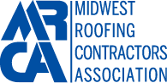
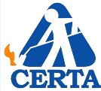
CERTA Materials and Mockup Instructions

Thank you for participating in the MRCA’s Certified Roofing Torch Applicator video conference based training program!
In order to effectively provide training in both the classroom and the practical hands-on training you must attend a video conference based classroom session and participate in a hands-on practical evaluation of your skills to demonstrate your understanding of the CERTA program’s requirements. This guide will provide you with the lists of materials and equipment required to complete both the classroom and the Hands-on
Evaluation components of the MRCA’s CERTA Training Program.
Classroom Training Materials
For each MRCA CERTA video conference based training program please have available the equipment and materials listed below.
- For each class group four people there must be a minimum of one laptop computer with broadband internet access. (see the instructions for joining meetings with MS Teams)
- The classroom must be equipped with at least one Video Camera, a Microphone and Speakers.
- Student manuals – one copy for each participant
- Roofing materials, including two small samples pieces of each of the following:

  - Wood fiberboard roof insulation
  - Polyisocyanurate insulation
  - DensDeck® gypsum board or equal
  - Perlite or Wood fiber cant strip
  - SBS Modified Bitumen Membrane
  - APP Polymer-Modified Bitumen Membrane
  - Heavy glass base sheet
  - Type IV glass ply sheet
  - Self-adhering, smooth base sheet

Hands-on Training Mockup Materials
For each video conference based training session you are required to perform a hands-on training and evaluation. To standardize training and facilitate the evaluations the MRCA recommends the fabrication of standard roofing mockups. Many companies already have these mockups as part of their on going training activities, others do not. If you do not have these mockups and desire to create a permanent training area in your company then please follow the mockup instructions below. If you do not desire to retain permanent mockups the MRCA has approved the use of a more basic set up that is disposable, those instructions follow.

Standard mockup materials

Quantity | Unit | Materials
192 | Sq. ft. | 1/4-inch fiberglass mat-faced gypsum core panel
3 | sheets | 4-foot by 8-foot by ½-inch CDX plywood
15 | Each | 2 x 4 dimensional lumber, 45-inch length
6 | Each | 2 x 4 dimensional lumber, 8-foot length
2 | Each | 2- by 12- or 14-inch construction-grade dimensional lumber, 12-foot length
150 | Each | 11/4-inch general-purpose screws
100 | Each | 16-penny nails
50 | Each | 3/4-inch tin-capped roofing nails
2 | Each | 9-inch metal pie tins, large coffee cans or galvanized tall cone flashings
2 | Each | 4-inch diameter steel pipe, 10- or 12-inch length
2 | Each | ½-inch plywood circles cut to 4-inch O.D. pipe size
2 | Each | 12-inch wood screws

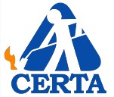
Materials and Mockup Requirements Page 2

For each session of 20 people please supply the following Hands-on Training installation materials.

Roofing Materials, per 20 participants | Quantity | Unit
Heavy fiberglass base sheet (#75-type) | 1 | Roll
Self-adhering polymer-modified base sheet | 1 | Roll
APP polymer-modified bitumen membrane—smooth or granulated | 9 | Rolls
Wood fiber cant strips—3-foot lengths (optional) | 8 | Each
Arrow T-50 staples for staple gun (or equivalent) | 1 | Box
Hooked blades for roofing knives | 10 | Each
Liquid soap (for leak detection) | 1 | Bottle

Hands-on Training Equipment Safety
Item | Quantity | Unit
4A-60BC fire extinguishers – up to date & sealed | 1 for each torch set
Type A first-aid kit | 1 | Each
Clean plastic 5-gallon pail (for water) | 1 | Each
Small plastic squirt bottle | 1 | Each
ANSI ZX-97 goggles (eye protection) | 1 for each participant
Leather-palmed heavy work gloves (hand protection)

Roofing Torches and Hand Tools

Roofing Equipment per 20 Participants | Quantity | Unit
20-pound vapor liquid petroleum (LP) gas cylinders | 4 | Each
Pressure regulators | 4 | Each
Pressure gauges | 4 | Each
25-foot UL-listed hoses | 4 | Each
Swivel-type connectors for torch assemblies | 4 | Sets
Propane roofing torches—detail application size not to exceed 105K Btu | 2 | Each
Propane roofing torches—field application size | 2 | Each
Spark-type igniters | 4 | Each
Adjustable wrenches | 2 | Each
Flat-blade screwdriver (for changing knife blades) | 1 | Each
Utility-type roofing knives | 4 | Each
Arrow T-50 staple gun (or equivalent) | 1 | Each
Large round-nosed trowels | 4 | Each
Mockup Design, Construction and Setup
The drawings below represent mockups to construct before conducting the hands-on training portion of this program.

Flat Deck Design
Construct a basic flat deck using 2 x 3 or 2 x 4 dimensional lumber secured with 16-penny nails as shown above. Install one layer ½-inch minimum CDX plywood to deck over the 2 x 4 frame, secured 8 inches on center with 11/4-inch general purpose screws. Install two layers of 1/4-inch fiberglass mat-faced gypsum core panel secured with 3/4-inch tin capped nails over the plywood. You will need to construct three basic flat deck mockups to

Materials and Mockup Requirements Page 3

conduct the hands-on training exercise. To create a simulated roof drain, cut a hole 18 inches from one side and 18 to 24 inches from one end in two of the three basic flat deck mockups. Use a 9-inch metal pie tin, large
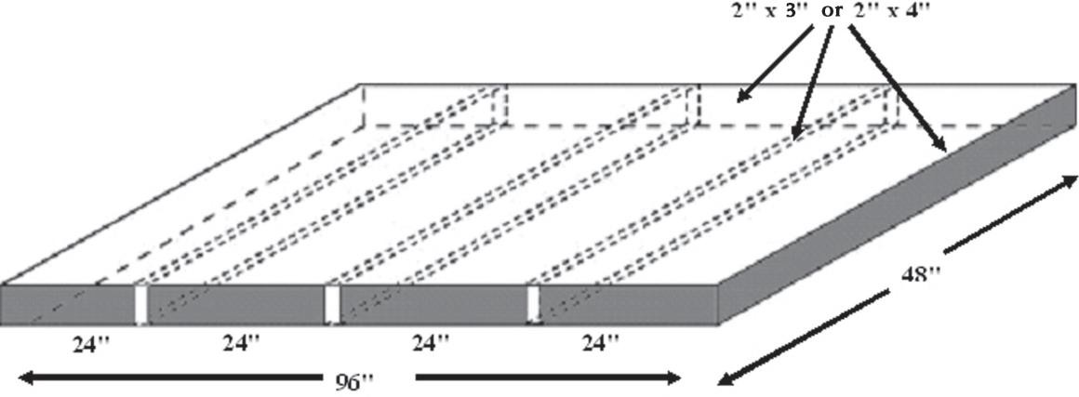
coffee can or an inverted galvanized steel “tall cone” flashing cut to height to simulate a roof drain opening.
Secure the simulated roof drain in the hole.

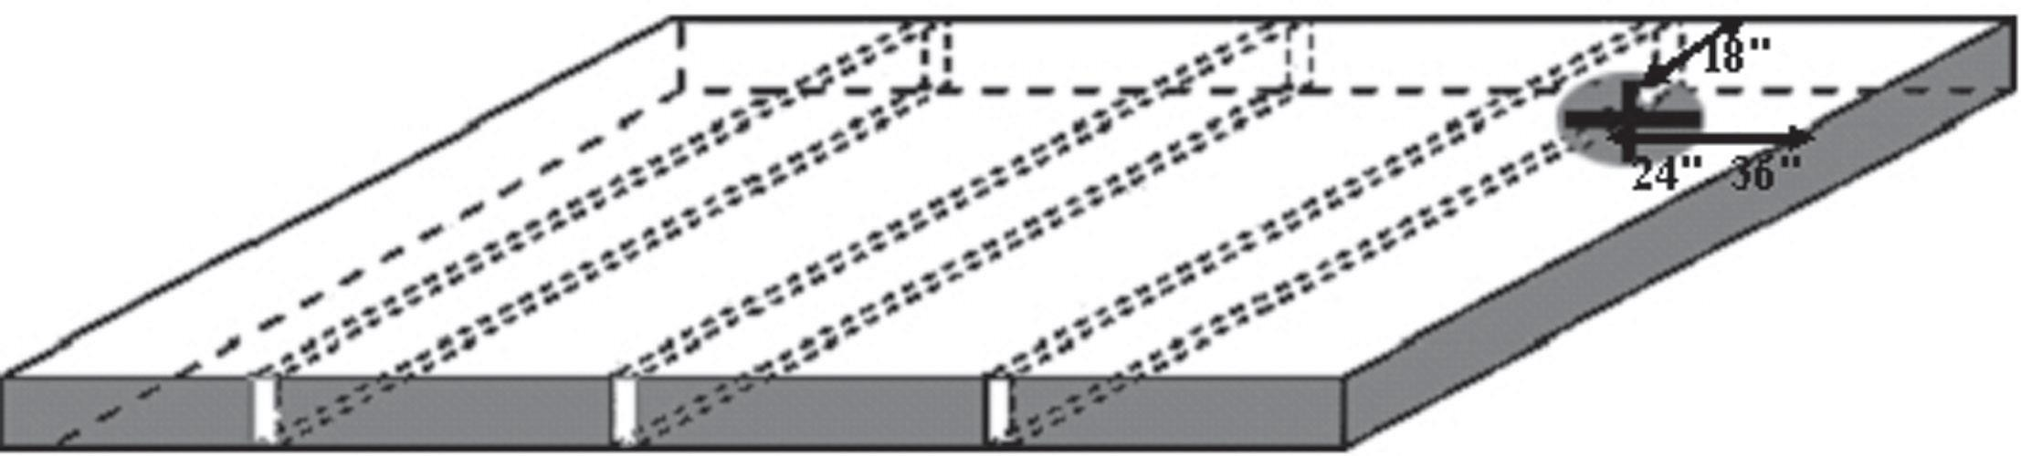
Simulated Roof Drain

Next, construct a basic pipe penetration mockup using a minimum 10-inch length of 3- or 4-inch pipe, a circular plywood disk cut to size of the outer pipe diameter and a screw 2 inches longer than the pipe length. Drill a hole near the center of the plywood disk to accept the screw. Secure the basic pipe penetration mockup at the opposite end of the basic deck mockup approximately 18 inches from one side and 24 inches from the end. The basic pipe mockup can easily be removed for storage.
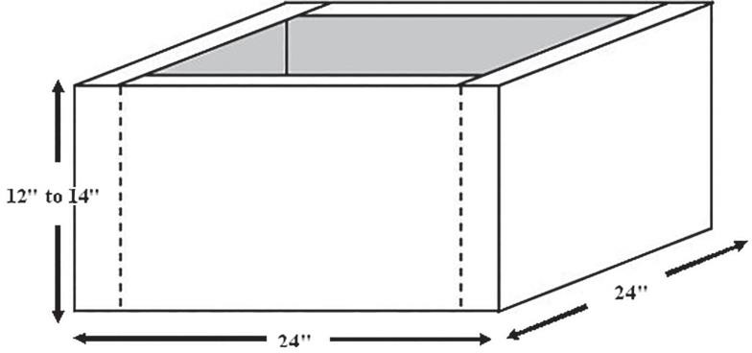
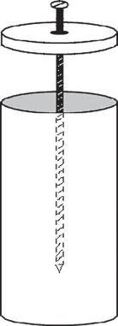
10”

Materials and Mockup Requirements Page 4

Begin your session by laying the three deck mockups side by side with the two drain openings at opposite ends. Cover the entire deck mockup layout with a heavy fiberglass base ply sheet stapled into place.

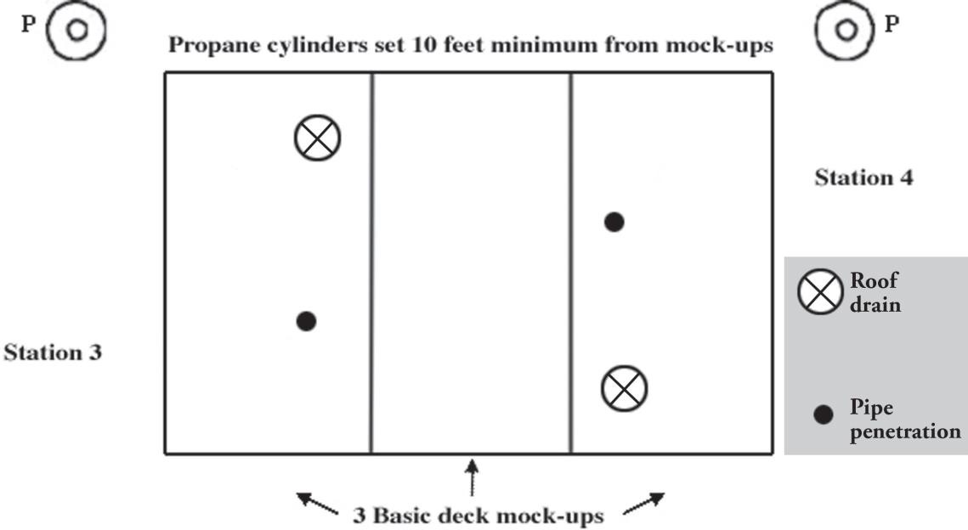

To facilitate the Evaluation Steps that require you to simulate roof edges or walls, on the floor or parking lot of your workspace use the following mockup layout:

- Lay 2 layers of fiberglass base ply ground protection for stations 1 and 2 at the flashing box areas.
- Set flashing boxes approximately 8 to 10 feet apart.
- Install cant strips around flashing boxes.
- Cover the flashing boxes and cant strips with heavy fiberglass base ply sheets stapled securely in place.
- Set two 20-pound fire extinguishers between the workstations.
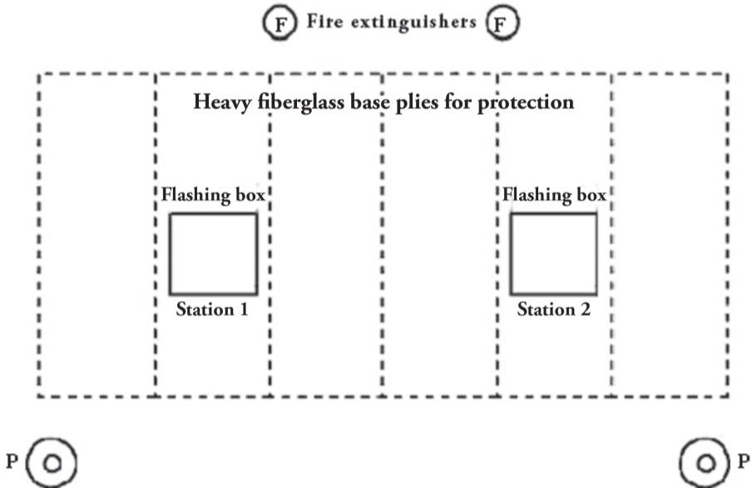
- Set 20-pound propane tank a minimum 10 feet away from each workstation.

Materials and Mockup Requirements Page 5

MRCA-CERTA Basic Mockups
For those contractors who do not have a dedicated training area or a small crew to train the MRCA will approve the use of an abbreviated mockup that is simpler to build and disposable. Your crew will still be required to demonstrate the safety concepts taught in the classroom portion of this program.

MRCA-CERTA Basic Mockup materials Materials
For every group of 8 to 10 people please provide the following materials.

Item | Quantity | Unit
4 x 8 Dens Deck Fiberglass Faced Gypsum 1/4" | 1
4 x 8 CDX Plywood 1/2" - (SCRAP is OK) plus a small quantity of cap nails (10 pieces x  1.5") | 1
3 Square roll #28 Fiberglass Base Sheet | 1
1 Square Roll 4 MM Smooth Modified Bitumen- Firestone APP 160 or Equal | 4
2" x 12" x 8' Cut into 4 x 24" pieces to create 2 x 90⁰ angle wood 1/2 curbs | 2
4" Aluminum pipe flashing with min. 4" flanges | 2
1 additional 1 Square Roll 4 MM Smooth Modified Bitumen for every 4 additional
trainees

On an open area of any concrete floor - lay out 2-3 layers of #28 glass base sheet to cover an area approximately 6' wide by 15' long to protect the floor. Lay out a roll of APP Modified Bitumen and cut it into 3 pieces approximately 11 feet long each. Back roll all 3 pieces and remove 2 from the area. On this base sheet each participant can torch down a section of the APP roll, practicing both starting and ending the roll and practicing a smooth, consistent torching rhythm to evenly heat the sheet and create a bleed out of the seam.

After all participants have completed the starting and finishing of a roll, on top of the base sheet lay out the 2 x 90⁰ angle wood 1/2 curbs. Your crew can then practice the indirect and direct torching technique on inside and outside corners. This will substitute for the drain detail.

When the inside/outside corner practice is complete, remove the half curbs and attach the pipe flashing to the to the Modified Bitumen using a 24” x 24” target piece. Each participant can then cycle through the pipe flashing details.

Simultaneously, in an area adjacent to your “field” area, lay the piece of scrap plywood against a wall or any surface that will support the plywood in a vertical position. You can finish a roll and practice the torch and flop techniques to install a wall flashing.

For any questions regarding technical issues or regarding the Hands-On Evaluation process please feel free to call at any time for support to (937) 306-2132 or email to CERTA.Eval@mrca.org

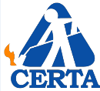
CERTA Pre Job Daily Inspection checklist

Inspector: |  | Inspection Date:
Project Name: |  | Building Owner’s Name:
Address: |  | Building Owner’s After- hours Telephone  Number:
Fire Department Telephone Number: |  | Police Department Telephone Number:
Emergency phone numbers | Posted locations: | Job-site no-smoking signs | Posted locations:

PROJECT GENERAL CONDITIONS
Deck Type |  |  |  | Wall Type
Above Deck Insulation |  |  |  | Insulation Attachment
Exposed roof edges |  |  |  | Low or poorly ventilated areas
Equipment and hose organization |  |  |  | Wind conditions
Changed conditions since previous day (e.g., combustible, or flammable
materials stored by building owner)
FIRE SAFETY
Local building codes and regulations |  | Specific codes discussed:
Official’s name:
Date contacted:
Official’s telephone
number:

DAILY PRE-START SAFETY INSPECTIONS |  | INSPECTED
Fall Prevention Systems | Walking Working Surfaces | YES NO
 | Perimeters – Rail/Cable Systems | YES NO
 | Perimeters – Warning Lines and Monitor | YES NO
 | Perimeters – Personal Fall Arrest Systems | YES NO
 | Holes/Skylights/Hatches | YES NO
 | Ladders | YES NO
PPE Inspection –  All Crew Members | CERTA Required (Long Pants/Shirts, Eyewear, Gloves) | YES NO
 | Project Required (Hi-Vis clothing, Hard hat, Shoes, etc.) | YES NO

CERTA Pre Job
Daily Inspection Page 2

EQUIPMENT - TORCHES, PROPANE GAS CYLINDERS & FIRE EXTINGUISHERS
Field Torches |  | Quantity |  | Condition | PASS# FAIL#
Detail Torches |  | Quantity |  | Condition | PASS# FAIL#
Propane Cylinders |  | Quantity |  | Condition | PASS# FAIL#
Extinguishers Size 4A60BC or Larger |  | YES NO |  | Quantity
Pins and Plastic seals in place |  | YES NO |  | Current Certification | YES NO
Location relative to torching activity
Location relative to cylinders

COMBUSTIBLE FLASHING SUBSTRATES
Flashing substrate type:
Adjacent or built in combustible building components | Cant strips - type: | YES | NO | Wood nailers | YES | NO
 | Door thresholds | YES | NO | Siding materials | YES | NO
 | Windowsills | YES | NO | Other | YES | NO
Concealed attic or crawl space areas | Access:

ROOFTOP MECHANICAL EQUIPMENT
HVAC or utility service lines | YES NO |  | HVAC units | Quantity
Wall louvers | Quantity |  | Air-filtering units | Quantity
Air intakes | Quantity |  | Water chillers | Quantity
Exhaust vents | Quantity |  | Condensing units | Quantity
Lint or sawdust collectors | Quantity |  | Other equipment | Quantity

PERIMTER EDGE, WALL OR FLASHING COMPONENTS
Counter-flashings | LF |  | scuppers | Quantity
Coping caps | LF |  | Others | Quantity
Gravel stop | LF |  | Drip edge | LF
Gutter | LF |  | Other

CERTA Pre Job
Daily Inspection Page 3

IN-PROGRESS INSPECTIONS – MID MORNING
Inspector: |  |  | Inspection Date:
Project Name: |  |  | Daytime Contact:
Under Deck Inspection | YES NO: |  | Unattended torches |  | YES NO
Housekeeping in Order | YES NO |  | Other
Infra-Red Thermometer Scans | Hot Spots Under Deck | YES NO |  | Hot Spots Above Deck |  | YES NO
 | Actions:

LUNCH BREAK FIRE WATCH
Inspector: |  |  | Inspection Time:
Under Deck Inspection | YES NO |  | Torches Off |  | YES NO
Housekeeping in Order | YES NO |  | Other
Infra-Red Thermometer Scans | Hot Spots  Under Deck | YES NO |  | Hot Spots  Above Deck |  | YES NO
 | Actions:

IN-PROGRESS INSPECTIONS – MID AFTERNOON
Inspector: |  |  | Inspection Time
Under Deck Inspection | YES NO |  | Unattended torches |  | YES NO
Housekeeping in Order | YES NO |  | Other
Infra-Red Thermometer Scans | Hot Spots  Under Deck | YES NO |  | Hot Spots  Above Deck |  | YES NO
 | Actions:

CERTA Pre Job
Daily Inspection Page 4

END OF DAY FIRE WATCH
Inspector: |  | After Hours Contact:
Fire Department Telephone Number: |  | Police Department Telephone Number:
Fire Watch Start | Time: | Fire Watch End |  | Time:
Under Deck Inspection | Time | Infra-Red Thermometer Scans - Hot Spots |  | YES NO
 | Time: |  |  | YES NO
 | Time: |  |  | YES NO
 | Actions Taken
Rooftop Inspection | Time | Infra-Red Thermometer Scans - Hot Spots |  | YES NO
 | Time: |  |  | YES NO
 | Time: |  |  | YES NO
 | Actions Taken
Housekeeping in Order | YES NO | Other
Rooftop mechanical equipment (list)
Walls and flashing components (list)
Perimeter edges (list)

EQUIPMENT STORAGE
LP Gas Cylinder Storage | All Cylinders Stored | GROUND ROOFTOP | Comments
 | Grouped Together | YES NO
 | Cylinder Valves Tightly Shut Off | YES NO
 | Secured | YES NO
 | Method Secured
Roofing Torches | Inspected for damage | YES NO | Comments
 | All equipment stored | YES NO
 | Other | YES NO
 | Other | YES NO

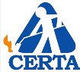
CERTA ROOFING TORCH APPLICATOR STUDENT FINAL EXAM

Name: | Date:

Carefully read each of the 25 questions. Choose the best answer for each question.

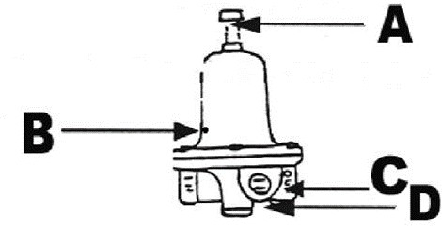
In the illustrated pressure regulator, which letter indicates the position of the vent hole?
  - A
  - B
  - C
  - D

The correct way to test for propane gas leaks is:
  - By sound
  - With a candle flame
  - Using a soapy water solution
  - By smell

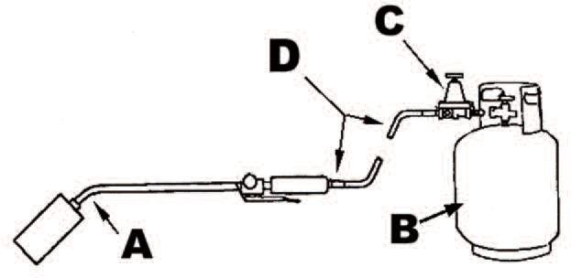
Identify torch assembly components by matching the correct letter below.

Pressure regulator

Hose and hose connections

Torching apparatus

Propane cylinder

To hoist a cylinder more than 30 inches, which of the following methods should be used?
  - Tie with a rope
  - Secure upright in a hoisting cage
  - Secure with a steel cable around the middle
  - Use the protective collar to tie the rope

CERTA ROOFING TORCH APPLICATOR STUDENT FINAL EXAM - PAGE 2

If your propane cylinder frosts and the pressure drops, it is an indication that you need to:

  - Heat the cylinder with a torch
  - Change to a larger cylinder
  - Lay the cylinder on its side to increase the pressure
  - Scrape the frost off the cylinder

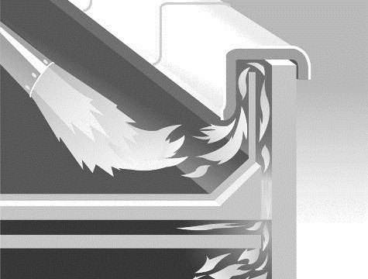
How can the fire hazard in the illustration best be avoided?

  - Wet down the wall

  - Use a fire axe

  - Install membranes using the torch-and- flop method

  - Leave the old flashings

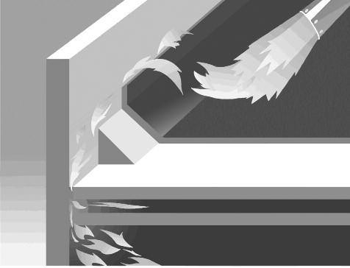
The wall flashing detail in this illustration uses a wood cant strip. What safety practice should be used to avoid a fire hazard?
  - Install a backer ply either mopped in place or self-adhered and ensure the laps are sealed
  - Apply additional heat to the base of the wall to make sure the cant strip does not burn

  - Do not adhere the membranes

  - Cover the wall with a fire blanket

All roofing torch applicators should be:
  - Trained as fire fighters, roof mechanics and in fire watch duties
  - Trained in fire extinguisher use, fire-hazards recognition and propane equipment safety
  - Instructed to wear appropriate PPE, have access to two 4A-60BC fire extinguishers within 10 feet and be certified
  - Both b and c

CERTA ROOFING TORCH APPLICATOR STUDENT FINAL EXAM - PAGE 3

- When plywood, wood plank, OSB or wood fiberboard roof deck substrates are present,
acceptable types of insulation boards that can be used as a thermal barrier include:
  - 1-inch extruded polystyrene, 2-inch cellular-glass or 1⁄2-inch wood fiberboard
  - 3-inch sprayed polyurethane foam, 11⁄2-inch polyisocyanurate foam or 1-inch mineral wool
  - 3⁄4-inch perlite, 3⁄4-inch fiberglass or 1⁄4-inch glass-faced gypsum board
  - None of the above
- Torch-and-flop, cold-applied, mop-applied or direct torching application techniques should always be used when you:
  - Start or end a roll of membrane at a wall or roof edge
  - Are not sure whether any material is combustible
  - Install field membranes around penetrations
  - All of the above
- A torch only should be lit using:
  - Cigarettes or cigarette lighters
  - Safety matches
  - Wooden kitchen matches
  - Flint or spark igniters
- If you leave a torch unattended, it must be:
  - Put into storage
  - Shut off
  - Set on its stand
  - Set on a coping or vent, off the roof surface
- If you put down a lit torch, make sure it is:
  - Put into storage
  - Shut off
  - Set on its stand
  - Set on a coping or vent, off the roof surface

CERTA ROOFING TORCH APPLICATOR STUDENT FINAL EXAM - PAGE 4

- A fire watch must continue for a minimum period of hour(s) after the last torch is
extinguished.
  - One-half
  - One
  - Two
  - Three
- A pre-job inspection daily checklist should include communicating with the:
  - Roofing crew
  - Building owner or owner’s representative
  - Foremen or superintendent
  - All of the above
- What classification of fire extinguisher should be within 10 feet of torching work?
  - 4A-60BC
  - “C”
  - Water cylinder
  - Halon
- Torch applicators should never:
  - Direct a torch flame in an area they cannot see
  - Lay a torch to rest over the edge of a roof
  - Torch directly to primers, adhesives, mastics or cements
  - All of the above
- Position propane cylinders a minimum of feet away from torching work areas.
  - 3
  - 5
  - 10
  - 15

CERTA ROOFING TORCH APPLICATOR STUDENT FINAL EXAM - PAGE 5

- What words does the term PASS stand for?
  - Pull, Aim, Squeeze, Sweep
  - Pull, Apply, Soften, Sweep
  - Place, Adhere, Sweep, Smooth
  - Pull, Adhere, Squeeze, Sweep
- In addition to a fire watch, other post-job requirements and duties include:
  - Setting up fall-protection equipment, loading materials and inspecting the underside of the roof deck
  - Cleaning sidewalks, driveways and parking lots
  - Grouping propane cylinders near the center of a roof, shutting off their valves and securing them in an upright position
  - None of the above
- When torching near rooftop equipment, inspect for the presence of fire hazards such as:
  - Loose bolts or screws, missing wires or rust
  - Cant strips, base plies or lead flashings
  - Birds, rodents or insects
  - Lint, grease or other combustible substances
- Direct torching of finish flashings sheets may take place only if:
  - A small “detail” torch (105k Btu or less) is used
  - Thermal barrier insulation is installed
  - Approved backer ply(s) are installed with sealed laps
  - Both a and c

CERTA Hands-on Performance Evaluation Form

Instructions for Evaluating Torch Operators

In this exercise you will observe eachroofingtorchoperator as he or she performs each step of the exercise. Circle the number you feel represents how well the operator per- formedoneachstep.Keepinmindthateveryoneusesatorchdifferently,soplease onlybaseyourscoresonthewayeachstepisdescribed.

TorchOperator’sName: | Date:

Scoring |  |  | You will score a 1 or a poor score if your teammate’s work does not meet the CERTA standards for safety. Score your teammate a 2 or give him a fair mark if he has accomplished the task but there was room for improvement. Your teammate will score a 3 or excellent because he is practicing all  the safety elements that the CERTA program requires
1 | 2 | 3
Poor | Fair | Excellent

Evaluation Step | Scoring
Step 1 – Lighting a torch
1. Wears proper PPE | 1 | 2 | 3
2. Closes all valves and opens regulator | 1 | 2 | 3
3. Points torch away from himself or herself and others | 1 | 2 | 3
4. Slowly opens cylinder valve | 1 | 2 | 3
5. Slowly opens pilot valve | 1 | 2 | 3
6. Uses a spark lighter | 1 | 2 | 3
7. Adjusts torch valve(s) | 1 | 2 | 3
8. Tests torch operation using trigger | 1 | 2 | 3
Step 2 - Flashing box stations 1 and 2: flashing torch and flop | Scoring
9. Wears proper PPE | 1 | 2 | 3
10. Measures and pre-cuts flashing strips | 1 | 2 | 3
11. Positions cut flashing strip upside down away from box curb | 1 | 2 | 3
12. Evenly heats back of flashing strips without damage to substrate | 1 | 2 | 3
13. Lifts flashing strip with trowel, grips it and flops it into place | 1 | 2 | 3
14. Presses flashing firmly into place | 1 | 2 | 3
15. Never touches the flashing box with use of high output torch | 1 | 2 | 3
Step 3 - Field mock-up stations 3 and 4: starting field membranes at roof  edges or walls | Scoring
1. Wears proper PPE | 1 | 2 | 3
2. Rolls membrane out 6 to 10 feet and positions in place | 1 | 2 | 3
3. Stands on roll and flops membrane back | 1 | 2 | 3
4. Evenly heats back of membrane without damage to substrate | 1 | 2 | 3
5. Lifts membrane with trowel, grips it and flops it into place | 1 | 2 | 3
6. Steps membrane in place and trowels lapped seam | 1 | 2 | 3
7. Never touches the wall or edge with a flame | 1 | 2 | 3
Step 4 - Field mock-up stations 3 and 4: installing target sheet at drain | Scoring
1. Wears proper PPE | 1 | 2 | 3
2. Measures and pre-cuts target sheet including finger cuts | 1 | 2 | 3
3. Positions cut target sheet upside down away from drain opening | 1 | 2 | 3
4. Evenly heats back of target sheet without damage to substrate | 1 | 2 | 3
5. Lifts target sheet with trowel, grips it and flops it into place | 1 | 2 | 3
6. Presses target sheet firmly into place with trowel | 1 | 2 | 3
7. Never touches the roof drain with a flame | 1 | 2 | 3

Page 1

CERTA Hands-on Performance Evaluation Form Page 2

Step 5 - Field mock-up stations 3 and 4: installing field membrane over drain | Scoring
1. Wears proper PPE | 1 | 2 | 3
2. Stops advancing roll before reaching drain | 1 | 2 | 3
3. Rolls membrane over drain without heating; marks and cuts drain opening | 1 | 2 | 3
4. Pulls roll back to expose bottom of membrane | 1 | 2 | 3
5. Evenly heats membrane without damaging substrate | 1 | 2 | 3
6. Lifts roll and flops the heated membrane over drain and into place | 1 | 2 | 3
7. Immediately steps membrane into place and trowels around drain and lapped seam | 1 | 2 | 3
8. Never touches the roof drain with a flame | 1 | 2 | 3
Step 6 - Field mock-up stations 3 and 4: installing field membrane around pipe penetration | Scoring
1. Wears proper PPE | 1 | 2 | 3
2. Stops advancing roll before reaching pipe | 1 | 2 | 3
3. Lifts and unrolls the roll backward, exposing underside of membrane far enough to  extend beyond pipe | 1 | 2 | 3
4. Pulls the extended membrane beyond penetration without heating and lays sheet  up against pipe | 1 | 2 | 3
5. Cuts and dry-fits membrane tightly around pipe | 1 | 2 | 3
6. Pulls membrane roll backward and lays it upside down away from pipe | 1 | 2 | 3
7. Evenly heats the membrane without damaging the substrate | 1 | 2 | 3
8. Lifts roll and lays the membrane into place around pipe | 1 | 2 | 3
9. Immediately steps heated membrane into place and trowels lapped seams | 1 | 2 | 3
10. Never touches the pipe with a flame | 1 | 2 | 3
Step 7 - Field mock-up stations 3 and 4: ending field membranes at roof edges and walls | Scoring
1. Wears proper PPE | 1 | 2 | 3
2. Stops heating the roll before reaching wall or edge | 1 | 2 | 3
3. Extends roll without heating to the wall or roof edge and cuts to length | 1 | 2 | 3
4. Pulls unheated membrane back to the point it is fully bonded to substrate | 1 | 2 | 3
5. Evenly heats the membrane without damaging the substrate; lifts heated  membrane using a trowel; grips it and flops it into place | 1 | 2 | 3
6. Immediately steps heated membrane into place and trowels lapped seams | 1 | 2 | 3
Never touches the wall or edge with a flame | 1 | 2 | 3
Step 8 - Shutting off the torch | Scoring
1. Sets lit torch down on its stand away from propane cylinder | 1 | 2 | 3
2. Walks over to cylinder and closes the valve tightly | 1 | 2 | 3
3. Returns to torch and squeezes trigger to burn out remaining gas from hoses and  regulator | 1 | 2 | 3
4. Closes all torch valves | 1 | 2 | 3

Thank you for participating int the MRCA’s Certified Roofing Torch Applicator Program!
Please remember to record the evaluation’s results on the final CERTA Roster and submit all forms and video clips withing 14 days of your course date by email to certa.eval@mrca.org

For any questions regarding technical issues or regarding the Hands-On Evaluation process please feel free to call at any time for support to the CERTA help line at (937) 306-2132

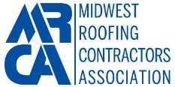
CERTA Applicator Training Program Final Exam Answer Key

Question | Answer
1 | B
2 | C
3 | C
4 | D
5 | A
6 | B
7 | B
8 | B
9 | C
10 | A
11 | D
12 | C
13 | D
14 | D
15 | B
16 | C
17 | C
18 | D
19 | A
20 | D
21 | C
22 | A
23 | C
24 | D
25 | D

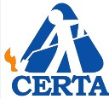
(2008-08-01)
No. Wrong | Score
-1 | 96
-2 | 92
-3 | 88
-4 | 84
-5 | 80
-6 | 76
-7 | 72
-8 | Fail

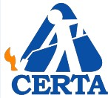
CERTA Video Conference Based Training Microsoft Teams User Guide

Thank you for choosing the Midwest Roofing Contractors Association CERTA Training Platform. We have selected Microsoft Teams as our training platform because of its widespread use in education across the country. Starting out with Microsoft Teams can be tricky if you are unfamiliar with the tool. Thankfully, it's cross-compatible with a number of devices, making it much easier to get started. You can use whatever device is most convenient to you, ranging from PC to tablet, including Apple devices.

MS Teams meetings enable interactive, collaborative meetings with people inside and outside of our organization. Companies and schools across the country also use Teams meetings to support remote learning and training with both internal and external audiences.

Key features
- Collaborate in real time using video & text chat
- Catch up on missed meetings with a video recording and searchable transcript.
- Join the meeting from any browser or using the Teams app on PC, Mac, Linux, iOS, and Android.
- Join via phone number using audio conferencing when internet connectivity is poor.

MRCA’s website will feature more information on how to schedule a training session and join our Microsoft Team (CERTA Landing Page). Upon registering for a CERTA training session, you will receive a code to join the “CERTA Channel”. Joining the “CERTA Channel” is optional, but you could lose out on some beneficial features. With the “CERTA Channel”, you can directly download class related files, view course announcements, and directly chat with your trainers in case you have questions. For access to these features within MS Teams you will have to create or sign in with a free Microsoft account.

If you would prefer to choose not to create a Microsoft account, you can still join your scheduled training session by clicking a link that we will provide in your confirmation package (similar to the Zoom platform). We have also created a dedicated email and phone lines with text capabilities to facilitate participation in the program.

Microsoft offers a beginner’s guide that you can read beforehand: https://howchoo.com/microsoft/how-to- use-microsoft-teams
Let's team up and get started!

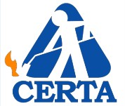
MRCA Certified Roofing Torch Applicator (CERTA) Training and Hold Harmless Agreement

This Training and Hold Harmless Agreement (this "Agreement") is made effective on the date of training by and between The Midwest Roofing Contractors Association and its Authorized Trainers (collectively, the MRCA - CERTA Trainer) and the MRCA Certified Roofing Torch Applicator trainee (defined as any class participant duly registered in the final class Roster, also known as the CERTA Trainee).

WHEREAS the CERTA Trainee desires to receive instruction in the MRCA’s Certified Roofing Torch Applicator Video Conference Based Training Program the Trainee agrees hold harmless the MRCA and the CERTA Trainer from any claims and/or litigation arising out of the Trainers actions in connection with MRCA Certified Roofing Torch Applicator program. NOW THEREFORE, in consideration of the mutual covenants and conditions contained herein, the CERTA Trainer and the CERTA Trainee hereby agree as follows:

TERMS

- Training: The CERTA Trainer will provide subject matter training in accordance with the Certified Roofing Torch Applicator program published by the National Roofing Contractors Association (MRCA) in the MRCA’s student manuals and videos and demonstrations by the CERTA Trainer.

- Hold Harmless. the CERTA Trainee shall fully defend, indemnify, and hold harmless The CERTA Authorized Trainer from any and all claims, lawsuits, demands, causes of action, liability, loss, damage and/or injury, of any kind whatsoever (including without limitation all claims for monetary loss, property damage, equitable relief, personal injury and/or wrongful death), whether brought by an individual or other entity, or imposed by a court of law or by administrative action of any federal, state, or local governmental body or agency, arising out of, in any way whatsoever, any acts, omissions, negligence, or willful misconduct on the part of the CERTA Trainee its officers, owners, personnel, employees, agents, contractors, invitees, or volunteers . This indemnification applies to and includes, without limitation, the payment of all penalties, fines, judgments, awards, decrees, attorneys' fees, and related costs or expenses, and any reimbursements to The CERTA Trainer for all legal fees, expenses, and costs incurred by it.

- Authority to Enter Agreement. Each Party warrants that the individuals who have signed this Agreement have the actual legal power, right, and authority to make this Agreement and bind each respective Party.

- Amendment; Modification. No supplement, modification, or amendment of this Agreement shall be binding unless executed in writing and signed by both Parties.

- Waiver. No waiver of any default shall constitute a waiver of any other default or breach, whether of the same or other covenant or condition. No waiver, benefit, privilege, or service voluntarily given or performed by a Party shall give the other Party any contractual right by custom, estoppel, or otherwise.

- Entire Agreement. This Agreement contains the entire agreement between the Parties related to the matters specified herein and supersedes any prior oral or written statements or agreements between the Parties related to such matters.

- Enforceability, Severability, and Reformation. If any provision of this Agreement shall be held to be invalid or unenforceable for any reason, the remaining provisions shall continue to be valid and enforceable. If a court finds that any provision of this Agreement is invalid or unenforceable, but that by limiting such provision it would become valid and enforceable, then such provision shall be deemed to be written, construed, and enforced as so limited. The intent of the Parties is to provide as broad an indemnification as possible under Ohio law. If any aspect of this Agreement is deemed unenforceable, the court is empowered to modify this Agreement to give the broadest possible interpretation permitted under Ohio law.

- Applicable Law. This Agreement shall be governed exclusively by the laws of Ohio, without regard to conflict of law provisions.

- Exclusive Venue and Jurisdiction. Any lawsuit or legal proceeding arising out of or relating to this Agreement in any way whatsoever shall be exclusively brought and litigated in the federal and state courts of Ohio. Each Party expressly consents and submits to this exclusive jurisdiction and exclusive venue. Each Party expressly waives the right to challenge this jurisdiction and/or venue as improper or inconvenient. Each Party consents to the dismissal of any lawsuit that they bring in any other jurisdiction or venue.

